**Seeing the Big Picture**

Understand how your role fits with and supports organisational objectives. Recognise the wider Civil Service priorities and ensure work is in the national interest.

## Who do you work for and What does the company do?

I work for the ministry of defence (MOD), they job is to protect the people of the UK from external threats, such as states outside the NATO alliance (like Russia, China, and North Korea, etc.), also from terrorist threats, and finally to establish peace and give back human rights to mistreated civilians living under a brutal violent dictatorship such as in Iraq by overthrowing the government.

As well as physical threats, the MOD also deal with cyber threats. Within the MOD I work in a section called ISS or Information System Services, the job of ISS is to protect against cyber threats mainly and also manage the maintenance of the MOD Network (MODNet). This is done my creating contracts with external company’s called MSP’s.

**Changing and Improving**

Seek out opportunities to create effective change and suggest innovative ideas for improvement. Review ways of working, including seeking and providing feedback.

## what are your goals and visions

my work goal is to one day work for a big tech company doing programming. I enjoy programming a lot, and a job like this would be of a huge interest to me. C++ has always been a language I want to learn in depth, I already know Python well and have worked on lots of smaller Python projects, such as a screen recorder, web crawling with selenium, and various other smaller projects. JavaScript is a language I know well too, having worked a lot with JavaScript and having used it to create various different websites along with HTML and CSS. My dream job would be software development programming.

**Making Effective Decisions**

Use evidence and knowledge to support accurate, expert decisions and advice. Carefully consider alternative options, implications and risks of decisions.

Here is an example of where I made an effective decision: A user told me their computer was running very slow, so I turned the computer on it took several minutes to boot and almost all programs crashed when I tried to open it, once it finally booted into the operating system desktop. After a lot of patience, I eventually managed to open task manager and saw some strange executable files running on the computer I had never seen before, I could see from the resource monitor part of task manager this programs using almost 100% CPU, hogging RAM, and was sending lots of data over the internet. I tried to close the program using end task, the program would not close not matter how many tied I tried to close it. I even went into the command line and even tried using “taskkill /f /im” but I got an error back saying “access denied”. I was running on an administrator user account how did I not have access to close this program hogging all the resources? Anyway I shut down the computer, and booted into safe mode. From there I started windows in safe mode with internet disable command line interface only. I then attempt to run an anti-virus scan using the users anti-virus software. The anti-virus detected the program as a threat and quarantined it.

I then booted the computer back into windows normally, and the computer seemed to work well, it was not slow anymore. It turns out that programs was a virus that I had just removed, booting into safe mode and running an anti-virus scan was the solution to the problem and allowed me to remove that malicious program.

So that’s an example of me problem solving, trying to close the program through the command line, looking at the program’s system resource usage in tasks manager, and finally removing the program by booting into safe mode and running an anti-virus scan.

**Leadership**

Show pride and passion for public service. Create and engage others in delivering a shared vision. Value difference, diversity and inclusion, ensuring fairness and opportunity for all.

I have show that I can be a leader many times through out my life, for example when I did a 10 day expedition to Iceland in 2015, I organised the entire thing myself and earnt the requirement amount of money, etc. I was the leader of a team of 3 other people (some friends), we walked around Öndverðarnes, past Hveragerði all the way to Reykjavík. I was responsible for mapping, and leading the team as to where we should walk, I also carried the emergency satellite phone and first aid kit, having been in scouts for 4 years I know a lot about first aid and how to treat various different injuries such as burns, cuts, and swelling.

In total the walk took 10 days, walking for about hours a day, then setting up the tent every night. It was a very long an tiring walk. But I saw some amazing things, from watching the birds fly past, to smelling the egg smell the sulpha dioxide produced from the volcano’s. on the last day, we got on bus that drove us to the Blue Lagoon. The blue lagoon was a wonderful place with green water, and sulpha enriched mud. I had great fun swimming in the warm naturally heated water, and rubbing the mud on me.

**Communicating and Influencing**

Communicate purpose and direction with clarity, integrity and enthusiasm. Respect the needs, responses and opinions of others.

Face to face

An example of face to face communication would be organising a 1v1 meeting with another work colleague, below is an example of me having a meeting with Lynne to discuss the OSM project work.

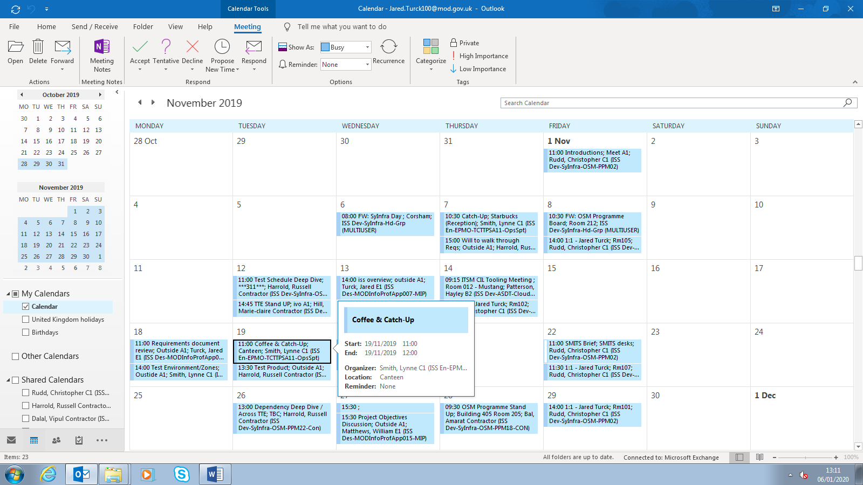

Oral

An example of oral communication is in meetings, I have meetings regularly where the whole team discuss the work they have been doing and we all can contribute to the conversation. The screenshot below shows a meeting in my calendar

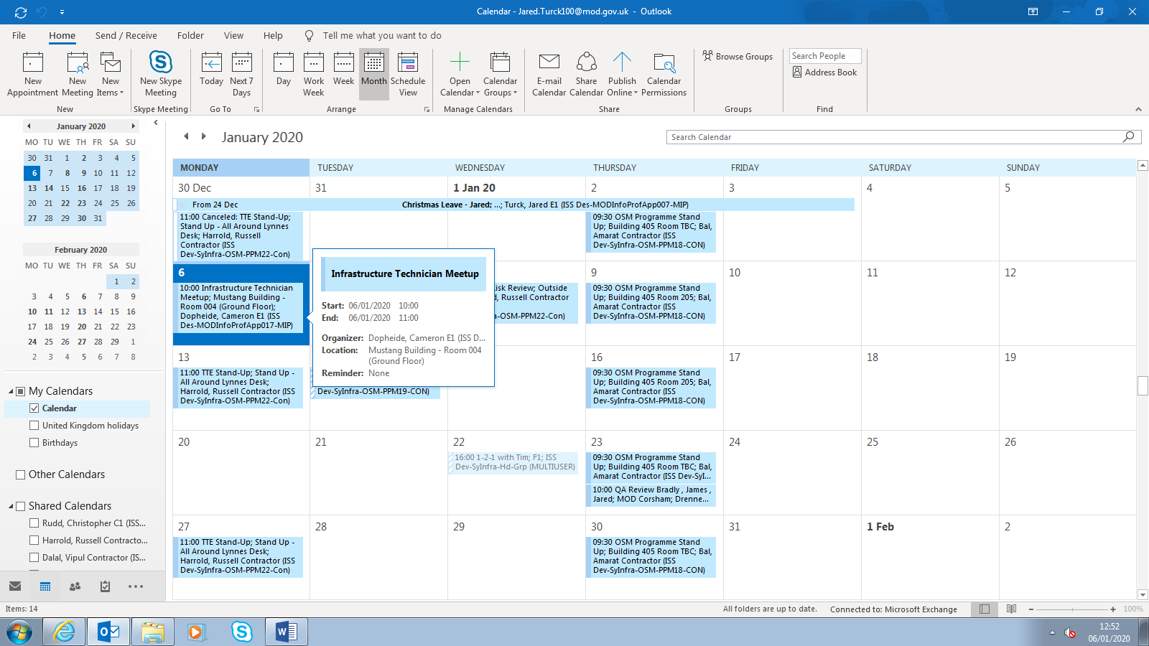

Remote

TeamViewer can be used to access a computer remotely and support a user, I have used TeamViewer countless times to fix an IT problem on a user’s computer. The screenshot below shows a user being asked if they want to allow, to take control of their computer.

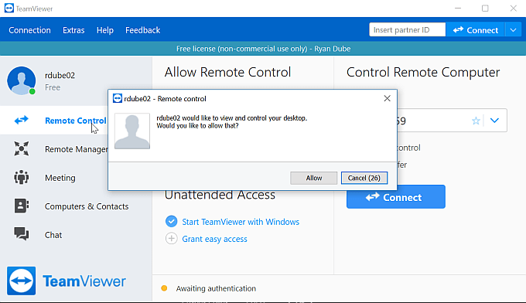

The screenshot above shows the TeamViewer client software.

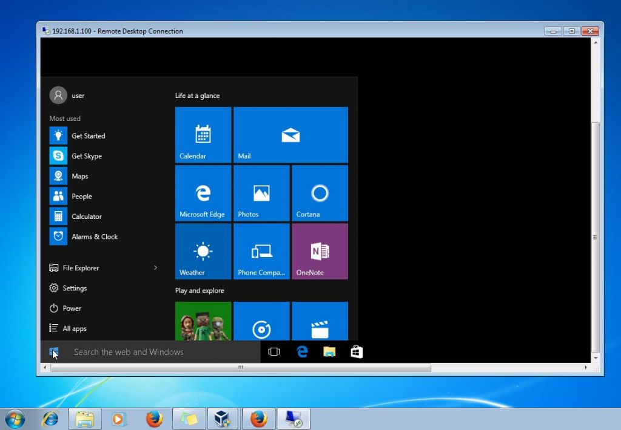

The screenshot above shows me connecting to a remote computer using TeamViewer and controlling their keyboard/mouse. Here you can see me opening the windows 10 start menu on a MOD clients personal computer, to help with a problem they where having where they could not access there emails.

## Which method do you prefer and which method is beneficial to the business.

I prefer instant message, it allows me to talk to anyone at any time, I don’t have to try organise a meeting and find a time where we are both free, instead I can just send them a message, they receive it and reply as soon as they are free or can do. IM is great for quick conversations. But for detailed conversations or if you have a large amount to say, a meeting is better as you can talk a lot faster orally instead of typing.

**Working Together**

Form effective partnerships and relationships with people both internally and externally, from a range of diverse backgrounds, sharing information, resources and support.

The screenshot below shows me giving support to another user through instant message, I designed an resource distribution system for him.

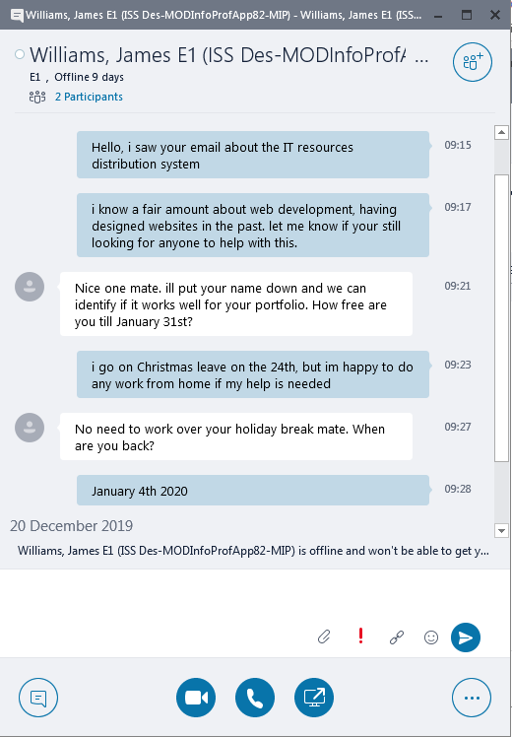

We are working together, as I am helping with design a resource management system.

**Developing Self and Others**

Focus on continuous learning and development for self, others and the organisation as a whole.

Problem solving is a very important part of developing yourself, here is how I problem solve

* The tools I use to solve a problem will greatly depend on what the problem is for example:
  + If I am having an IT issue, such as a problem is not opening, one way to solve that problem would be to go to task manager and shut down the running application then reopen it. In this particular case I am showing that I know how to use an appropriate tool such as task manager to fix an issue with a program not opening.
  + Lets say I’m having another issue where I cant connect to the internet, when I open a web browser like Google Chrome it comes up with a no internet access error message. One tool I could use to solve this issue would be to click on the networking icon in the task manager and open the networking and internet settings, then select the network that I would like to connect to. Here I am showing that I know how to use the settings tool, to reconnect to a network and gain internet access back.
  + Lets say again I’m having another issue but this time I cant login to skype I forgot my password, one tool I could use is Outlook to contact an IT administrator. I can use Outlook to send them and email and request a password reset. In this case, I’m using the outlook tool to ask someone to do something for me, which in turn is going to solve the issue as my password would be reset and I can log back into Skype.

Another very important part of developing yourself is having the tech knowledge to understand and complete technical tasks.

* Software:
  + I have shown that I know how to how to configure the networking settings in order to connect to the MOD VPN on MacBook Pro laptop when I was working for ASDT.
  + I have shown that I know how to configure the printer settings, for example to select the correct printer, right paper size, and print quality, when printing documents.
  + I have shown that I know how to configure the bookmark bar in google chrome to save links to websites I frequently use. This allows me to quickly access websites like SharePoint or OneDrive by simply clicking the bookmark instead of having to manually search for it.
* Hardware:
  + I have shown that I know how to plug headphones into a computer, by locating the headphone jack on the front IO ports of the computer case.
  + I have shown that I know how to unplug an ethernet cable and re-plug it into a different computer, for example when setting up the MOD laptop in order for the laptop to connect to MODNet it needed to directly connected with a wired ethernet cable to the network, so that it could setup my user account login.
  + I have shown that I know how to connect peripherals such as keyboard and mouse to a computer via the USB ports, and also how to unplug the screen of the computer by disconnecting the VGA cable.

**Managing a Quality Service**

Deliver service objectives with professional excellence, expertise and efficiency, taking account of diverse customer needs.

A very important part of managing a quality service, is the ability to communicate with everyone, regardless of there diversity, or other factors, here is how I can communicate

* I show shown that I can communicate orally by contributing to a conversations in meetings, and also through a microphone when attending skype meetings.
* Face-to-face, I have shown that I can communicate face to face, by attending the Friday catchup meetings with Chris Rudd (my line manager). Before the whole coronavirus pandemic, every Friday Chris would organize a one on one meeting to discuss what I had done and I would talk to him face to face.
* Remote, I have shown that I can communicate remotely through skype meetings on the MOD laptop. Due to the pandemic, I have had to work from home resulting al all meetings currently being held remotely over skype.

**Delivering at Pace**

Take responsibility for delivering timely and quality results with focus and drive.

In order to ensure I meet deadlines I use workflow management

* I have shown that I know how to manage and priorities tasks, by settings reminders in outlook to complete particular task by a specific date. The reminders feature of outlook is very useful tool for prioritizing tasks, as it allows you to define what is in scope currently and what is out of scope that needs to be completed at a later date.
* I have shown that I know how to record tasks that I have done, by saving emails people send me requesting work to be done, this allows me to refer back to those emails if I ever need to. Another way that I have shown that I know how to record tasks is by writing down what I have done every day in my worklog spreadsheet. The worklog spread sheet is a document on SharePoint where I write what I have done, then my manager Chris can check it. It allows him to ensure that I am doing the work, and that the work is logged for future reference.